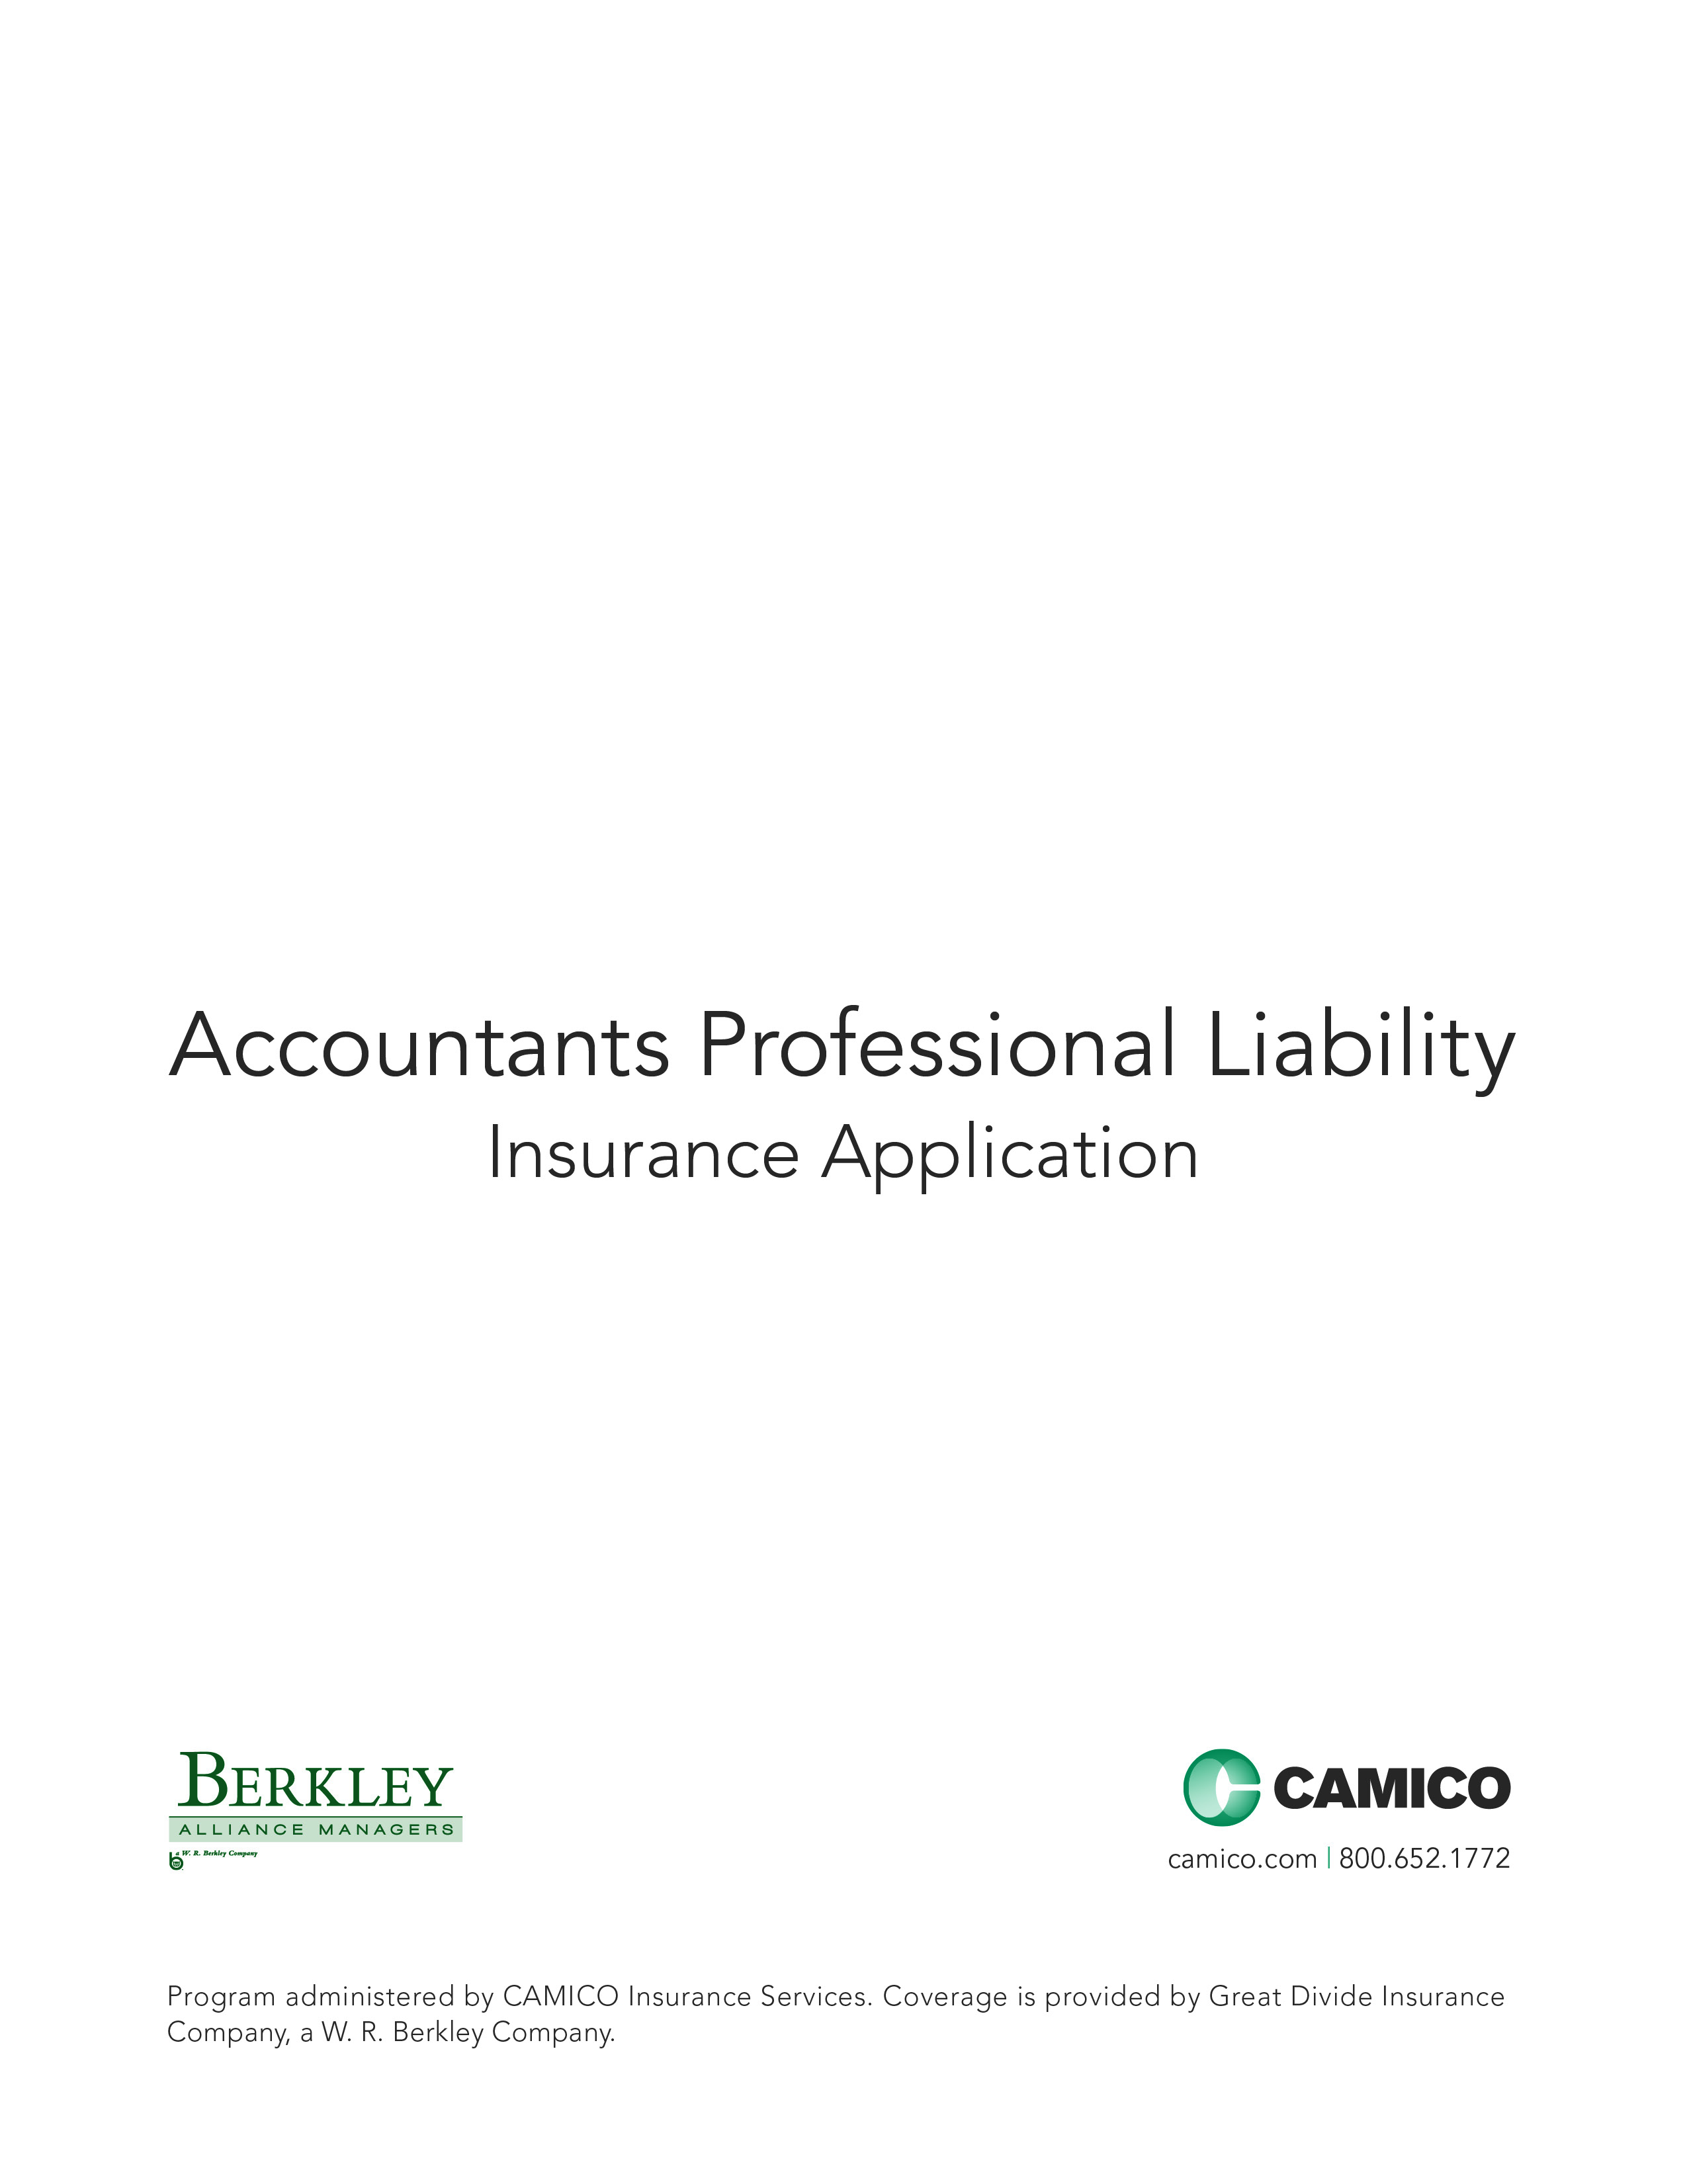

ACCOUNTANTS PROFESSIONAL LIABILITY INSURANCE APPLICATION

This is an application for a “Claims Made and Reported” policy. The policy applies only to claims first made against the Insured and reported to the Company while the policy is in force and for professional services performed on or after the prior acts (or retroactive) date. The limit of liability available to pay damages or settlements shall be reduced by amounts incurred as “Claim Expenses,” including fees and expenses incurred in the investigation, adjustment, and defense of a claim. The policy will be issued in reliance upon the statements in the application. Therefore, it is important that all questions be answered accurately.

Please follow the steps listed below to complete your application:
- Type or print clearly, and do not use pencil.
- Complete Parts I through VIII, answering all questions completely. If any question, or part thereof, does not apply, put “NA” in the space provided - leave no blanks. Failure to answer all questions will delay our ability to underwrite this application, which may result in a gap in your coverage.
- Complete supplemental application(s) only when appropriate.
- Sign on page 8 and make a copy of the completed application for your records.

Part I: Firm Information

- Firm Name:

- Contact Person:
(Person designated and authorized by the Firm to receive any and all notices concerning this insurance.)

- Contact Person Title: 4. Contact Person Email Address:

- Primary Office Address:
Street Address City County State Zip
If Firm has other locations or shares office space, complete the Multiple Offices/Shared Office Space Supplement (S-1).

6. Telephone: 7. Fax: 8. Web Site:

9. Mailing Address:
(If different from #5) Street Address City County State Zip

10. Entity Type: Sole Proprietorship Partnership Corporation LLP LLC PC Other (list):

11. Firm Established (mm/dd/yyyy):
(Attach firm owner resume(s) or Work History(s) if firm established date is less than three (3) years ago.)

12. Within the last five (5) years has the Firm merged or acquired another business? Yes No

If “Yes”, please complete the Merged or Acquired Firm(s) Supplement (S-2.1).

13. a. Has the staff size of the Firm changed +/- 25% during the past three (3) years? Yes No
b. Have the Firm’s service areas shifted significantly in the past three (3) years? Yes No

If “Yes” to a. or b. above, please explain on the Narrative Response Sheet on page 7.

14. Are there any material changes pending in the organization of the Firm including but not limited to merger, acquisition, other restructuring, addition of a new client industry or scope of practice? Yes No

If “Yes”, please explain on the Narrative Response Sheet on page 7.

15. Has the Firm or any owner, partner or officer rendered professional services or conducted
business activities (other than for a previous employer) under a separate entity within the last five (5) years? Yes No

If “Yes”, please complete the Separate Entity Supplement (S-2.2).

Part II: Firm Profile

16. List Name(s) of all proprietors, partners, or stockholders. Please use the Narrative Response Sheet, if necessary.

Name | % Ownership Only if Non-CPA | Title | Year of CPA License | E-mail Address

- Does the Firm or any Firm member belong to: AICPA? State CPA Society?
- List any AICPA Practice Section or quality center that the Firm belongs to: (e.g. PCPS; GAQC; EBPAQC; CAQ)
- List any national or international CPA Group or Association that the Firm belongs to:
- Is the Firm licensed and in good standing for the state(s) in which it operates? Yes No

17. Firm Staff (include contract and per diem employees who work 500 or more hours per year):

 | CPAs | Non-CPAs | Total

Owners, Partners, Officers

All Other Accounting or Tax Professionals

Other Consulting Professionals (not included above)

Administrative Staff

Total

18. Does the Firm, any Firm member, subsidiary or affiliate Firm member maintain a non-CPA Professional License? Yes No
If “Yes”, please complete the Professional License Supplement (S-9).

19. a. Within the past five (5) years, has the Firm or any member of the Firm, its predecessors or affiliates had his/her certificate, license, or permit to practice placed on probation, suspended or revoked or voluntarily surrendered due to an investigation? Yes No
b. Within the past five (5) years, has the Firm or any member of the Firm, its predecessors, or affiliates been subjected to any disciplinary action by any State Board of Accountancy, State Society, the AICPA or any other State or Federal regulators? Yes No
c. Within the past five (5) years, has the Firm or any member of the Firm, its predecessors, or affiliates been charged, indicted or convicted of a felony? Yes No
d. Is the Firm or any member of the Firm currently under investigation by any of the above named boards, societies or regulators? Yes No

If “Yes” to a., b., c. or d. above, please explain on the Narrative Response Sheet on page 7.

20. Based on the Firm’s fiscal year-end data, provide the following gross revenue figures
[Firm fiscal year ends (mm/yy)]:

Next Fiscal Year ( )  (projected) | Current Fiscal Year ( ) (estimated) | Last Fiscal Year ( ) | Previous Fiscal Year ( )
$ | $ | $ | $
21. a. Percentage of revenue from the Firm’s largest clients (including related entities):
Largest: % Second Largest: %

For those clients representing 20% or more of the Firm’s revenue, please list for each: client name, client industry, services performed, and length of time as a client; describe how the Firm maintains its independence and advise how the Firm plans to reduce this percentage in the next two (2) years on the Narrative Response Sheet on page 7.
b. Percentage of revenue from Per Diem work for other CPA firms? %
Provide firm names on Narrative Response Sheet on page 7.

Part III: Scope of Practice

22. Approximately what percentage of the Firm’s revenue is derived from the areas listed below?
Please indicate whether or not engagement letters are used for each service area listed below.

% of Revenue

Engagement
Letter Used
Service Area
Service Area
% of Revenue

Engagement
Letter Used

Tax
• Business Tax ........................................................ % Yes No
• Estate Tax ............................................... % Yes No
• Individual Tax ..................................................... % Yes No

Accounting/Bookkeeping
• Accounting/Bookkeeping ........... % Yes No

Consulting
• Merger & Acquisition ........................ % Yes No
(Describe on Narrative Response Sheet)
• Computer-Related Services ...... % Yes No
(Complete Supplement S-3.4)
• Litigation Support ....................................... % Yes No
• Management Consulting/
Business Planning ...................................... % Yes No
(Describe on Narrative Response Sheet)
• Projections/Forecasts ......................... % Yes No
• Valuations .................................................................. % Yes No
• Other .................................................................. % Yes No
(Describe on Narrative Response Sheet)

Attestation
- Audit (Complete Supplement S-3.1)
- Non Public ................................................................. % Yes No
- Public ................................................................................... % Yes No
• Agreed Upon Procedures ................ % Yes No
- Review ................................................................................. % Yes No
- Compilation ............................................................. % Yes No
Special Services
• Client Funds Controlled
(Including Business Management
and Family Office Services). % Yes No
(Complete Supplement S-3.2)

• Non-Trustee Fiduciary or
Administrative Responsibility-
ERISA, Pension & Benefit Plans,
ESOPs, Insurance Co.’s, Hedge
Funds, other Investment Co.’s ............ % Yes No
(Describe on the Narrative Response Sheet.
For all pension/benefit funds, provide a client list
including asset size and number of participants)
• Executor/Trustee/Receiver ................ % Yes No
(Complete Supplement S-4)

• Investment/Financial
Planning ....................................................................................... % Yes No
(Complete Supplement S-5)

• SEC-Section 404 Services ..................... % Yes No
(Attach Client List)

• SEC Work other than Audit,
Section 404 Work or Tax ......................... % Yes No
(Describe on the Narrative Response Sheet)

Other
• Other ............................................................................................... % Yes No
(Describe on the Narrative Response Sheet)

TOTAL ADDS TO 100% 100 %
23. Does the Firm, or any Firm member, control or distribute client funds, other than as trust protector, trustee, executor, receiver, administrator or personal representative? Yes No

If “Yes”, please complete the Funds Controlled Supplement (S-3.2).
24. Has the Firm, any Firm member or spouse, within the past five (5) years:
a. Held an equity interest in, operated, or managed any entity (excluding the Firm) for whom the Firm provided professional services? Yes No
b. Acted as a director, officer or exercised any form of managerial control over any entity (excluding the Firm), for whom the Firm provided professional services? Yes No

If “Yes” to a. or b. above, please complete the Outside Activities Supplement (S-7).
25. Has the Firm, or any Firm member, acted as trust protector, trustee, co-trustee, executor, receiver, administrator or personal representative, other than for life insurance trusts or trusts with less than $500,000 in assets? Yes No

If “Yes”, please complete the Executor/Trustee/Receiver Supplement (S-4).
26. Has the Firm, its predecessors, or affiliates, within the past five (5) years:
a. Performed audits for or provided consulting services to SEC-regulated entities (other than broker/dealers who are not publicly traded)? Yes No
b. Performed services, or consented to the use of the Firm’s work product, in connection with public or private offerings of securities, real estate, or other investments? Yes No
- Performed services in connection with any reverse merger? Yes No

If “Yes” to a. or b. above, please complete the SEC Supplement (S-8.1).
If “Yes” to c. above, please provide detailed explanation on the Narrative Response Sheet on page 7.

27. Is the Firm in the process of or planning to bid on any new engagements for a publicly held
company, its subsidiaries or its employee benefit plans? Yes No

If “Yes”, please describe, including name of proposed new client, on the Narrative Response Sheet on page 7.

28. Has the Firm, its predecessors or affiliates, within the past five (5) years performed services
other than tax services for hedge funds, real estate or investment syndicates, private equity funds,
venture capital funds or any entities engaged in the sale of unregistered investment products? Yes No

If “Yes”, please complete the Unregistered Investment Vehicle Supplement (S-5.1).

29. Has the Firm, its predecessors or affiliates, within the past five (5) years performed services for Financial Institutions? Financial institutions are defined as Banks, Bank Holding Companies, Savings Associations, Savings and Loans, Credit Unions, Thrifts, Insurance Companies, Investment and Mortgage Banks. Yes No

If “Yes”, please complete the Financial Institution Supplement (S-8.2).

30. Does your Firm or affiliate provide services to entities under the guidelines of ERISA? Yes No

If “Yes”:
a. Are actuarial services performed? Yes No
b. Is the Firm or affiliate involved in plan design or qualifying plans or their amendments? Yes No
c. Does the Firm or affiliate act as a fiduciary or advisor, or recommend investment or mutual funds to which the Firm provides other accounting services or acts as a director or officer? Yes No

If “Yes” to c. above, please provide a full description of Firm services on the Narrative Response Sheet on page 7.

31. Has the Firm, its predecessors or affiliates, within the past five (5) years provided any non-financial services regarding the care received by an individual (for example: providing assurances regarding care received, consulting on client care options, providing assistance with daily activities, coordinating the provision of such services for or at the direction of any client for others)? Yes No

If “Yes”, please describe on the Narrative Response Sheet including services provided and annual revenue.

32. Has the Firm, its predecessors or affiliates, within the past three (3) years:
a. arranged debt or equity financing or acted as a business broker? Yes No
b. acted as a mortgage agent/broker? Yes No
c. performed actuarial services? Yes No

If “Yes” to a., b. or c. above, please provide a detailed description of services performed for each such client, including a sample engagement letter for these services, on the Narrative Response Sheet on page 7.

33. Does any Firm member serve as a temporary employee or interim CFO for others? Yes No
If “Yes”, please complete the Temporary or Interim CFO Supplement (S-13).

34. Does the Firm outsource, delegate, sub-contract and/or have any split fee arrangements? Yes No

If “Yes”, please describe on the Narrative Response Sheet the nature of the services, and length of engagement.

35. Does the Firm provide services for any entity domiciled outside of the U.S.? Yes No

If “Yes”, please describe on the Narrative Response Sheet the nature of the services, indicate the country in
which services are performed, and advise if any of these services are performed for non-US domiciled SEC regulated entities.

36. Has the Firm, its predecessors or affiliates, currently, or within the past five (5) years:
a. Organized, sold, acted as sales promoter or sales agent for, or participated in the management of or general partner for any real estate or other investment syndicate, limited liability company (“LLC”) or partnership (limited or general)? Yes No
b. Received any compensation, including commissions, finder fees, reciprocity or participation from sellers or promoters of an investment, tax shelter, securities, insurance products, or real estate? Yes No

c. Organized, sold, acted as sale promoter or sales agent for, prepared any promotional sales materials for, provided any tax advice, counsel or opinions with respect to, any “reportable transaction” as defined in Treasury Regulation §1.6011-4(b) or Internal Revenue Code §6707A(c) (and any regulations thereunder), or acted as a material advisor (as defined in Internal Revenue Code §6111(b)(1) and Treasury Regulations §301.611-3(b))? Yes No
d. Organized, sold, acted as sale promoter or sales agent for, prepared any promotional sales materials for, provided any tax advice, counsel or opinions with respect to, or prepared or assisted in preparing any income, gift or estate tax returns incorporating or reporting a tax shelter or other tax advantaged investment which provided taxable income exclusions or tax deductions exceeding $500,000 in any one tax year? Yes No

If “Yes” to a., b., c. or d. above, please provide detailed explanation on the Narrative Response Sheet on page 7.

Part IV: Business Practices

37. During the past five (5) years, has the Firm or its affiliates sued to collect fees, including in small claims court? Yes No

If “Yes”, provide a list of all outstanding amounts owed, date of suit, services rendered, current status, whether still a client and if an engagement letter was used on the Narrative Response Sheet on page 7.

38. Indicate what loss prevention tools your Firm requires Firm members to use.

Should the Firm become a Great Divide Insurance Company policyholder, significant resources will be available to help you augment your risk management practices.
Note

a. Engagement letters are updated:
Annually for all engagements Annually for attest engagements
As engagement changes Evergreen (not updated)
Other: Not used

b. Second person/partner review of:
Attest services Tax services
All services Other:
No second person/partner review of any services

c. Checklists:
AICPA PPC
Other: Not used or not applicable

d. Client screening procedures:
New clients prior to acceptance Existing clients
Both None

e. Do engagement letters contain ADR (Alternative Dispute Resolution) or Limitation of Liability clauses? Yes No
f. Does your Firm have disengagement procedures for terminating client relationships? Yes No
g. Are declination/non-engagement letters used on all matters declined by the Firm? Yes No
h. Does your Firm have a written policy prohibiting business ventures with clients of the Firm? Yes No
i. Does the Firm have a written internal quality control document? Yes No
If “No”, please provide an explanation on the Narrative Response Sheet on page 7.
j. Does your Firm have a formal fraud awareness and detection program in place? Yes No
k. Other loss prevention tools/procedures (describe):

39. Date of most recent peer or quality review:

If not within last three (3) years, and you are subject to on-site review, what is the anticipated date of your next
review? mm/yy
If no review is planned, please provide an explanation on the Narrative Response Sheet on page 7.

a. Was the review on-site or off-site? On-site Off-site
b. Were the review results “pass with deficiencies” or “fail” (or if your state has not adopted the new Peer Review standards, were the results “modified”, “qualified”, “adverse” or “other”)? Yes No

If “Yes” to b. above, please provide a copy of the letter of comments, your Firm’s response and
committee acceptance letter.

Part V: Claims Information

40. To the knowledge of the Firm, after inquiry of Owners/partners and employees, have any claims or
suits involving malpractice been made against the Firm, a predecessor Firm, a subsidiary or affiliate
entity, any partner, stockholder and/or professional staff person:
a. During the past five (5) years? Yes No
b. Anytime and remains open? Yes No

If “Yes” to a. or b. above, please complete the Prior and Existing Claim/Incident Supplement (S-10).

41. Is the Firm, after inquiry of stockholders, partners and employees, currently aware of any incidents, circumstances, disputes, fee problems, or employee problems, which may result in any claim being made against the Firm, its predecessors, subsidiaries, affiliates or any partner, stockholder or employee? Yes No

If “Yes”, please complete the Prior and Existing Claim/Incident Supplement (S-10).

42. Has any professional liability insurance for the Firm, a partner, stockholder, employee of the Firm, its predecessors or subsidiaries ever been declined, canceled, or non-renewed?
(Not applicable in Missouri) Yes No

If “Yes”, please explain on the Narrative Response Sheet on page 7.

Part VI: Coverage

43. Has the Firm carried accountants professional liability insurance in the past three (3) years? Yes No

If “Yes”, please complete the following and provide a copy of your most recent Declarations page and all endorsements on your policy that exclude, add or modify coverage:

From/To  (mm/dd/yyyy) | Insurance  Company | Limit of Liability  (Per Claim/Aggregate) | Deductible | Premium
From: / /
To: / /
From: / /
To: / /
From: / /
To: / /

44. Does your current policy contain a prior acts limitation or retroactive date? Yes No

If “Yes”, please provide the date:
- Limits of liability and Deductible options: (check all options you wish quoted)
Requested Limits (Per Claim / Annual Aggregate):
$100,000 / $100,000 (Not available in CA) $250,000 / $250,000 $500,000 / $500,000
$500,000 / $1,000,000 $1,000,000 / $1,000,000 $2,000,000 / $2,000,000
$3,000,000 / $3,000,000 $4,000,000 / $4,000,000 $5,000,000 / $5,000,000
Other: $
Requested Deductible (Per Claim):
$2,500 $5,000 $10,000 $25,000 Other: $
Additional Coverage Options

Separate Defense Limit:

Dollar One Defense

Defense-only coverage – Directors & Officers – Non-profit 501(c)(3)
Please complete the Community Service Defense Coverage Application (S-12).

Increased limits for Misappropriation of Client Funds sub-limit:
(Cannot exceed limit of liability requested in basic coverage above)

Defense-only coverage - Employment Practices: Please complete the Employment Practices Defense Coverage Application Supplement (S-11).

Part VII: Narrative Response Sheet

Question # | Explanation

Part VIII: Signatures

The undersigned proprietor, authorized partner of the partnership, or authorized stockholder of the corporation represents that the following statements are understood and agreed to by the applicant:

By signing this application, the undersigned represents that he or she has made inquiries of all Firm members as appropriate and that all Firm members are bound by the representations made on this application, any supplemental application, and any supplemental data and documents provided.

Signing this application or tendering premium does not bind the applicant or the company to issue insurance coverage, but it is agreed that this application shall be the basis of the contract should a policy be produced.

After inquiry of all stockholders, partners and employees, the undersigned is not currently aware of any act, error, omission, incident, circumstance, dispute, fee dispute or employee problem, which could reasonably be expected to be the basis of a claim being made against the Firm, its predecessors or any partner, stockholder or employee, that has not been reported to another insurer. It is understood and agreed that any claim emanating from such knowledge or information shall be excluded from coverage under the proposed policy.

IMPORTANT: Great Divide Insurance Company intends to rely upon your answers to questions in this application and any attached supplements in reaching its decision to offer coverage and/or to offer coverage excluding any described activities. Inaccurate responses to inquiries may result in a loss of coverage for activities and/or a decision by Great Divide Insurance Company to rescind the entire policy. Your signature below acknowledges your understanding of this notice.

FRAUD WARNINGS – Residents of Alabama, Arkansas, Colorado, District of Columbia, Florida, Kentucky, Louisiana, Maine, Maryland, New Jersey, New Mexico, Ohio, Oklahoma, Oregon, Pennsylvania, Rhode Island, Tennessee, Virginia, Washington and West Virginia

NOTICE TO APPLICANTS: Any person who knowingly and with intent to defraud any insurance company or other person files an application for insurance or statement of claim containing any materially false information or conceals for the purpose of misleading, information concerning any fact material thereto commits a fraudulent insurance act, which is a crime and may subject a person to criminal and civil penalties, including but not limited to fines, denial of insurance benefits, civil damages, criminal prosecution and imprisonment.(Notice to Colorado resident applicants: It is unlawful to knowingly provide false, incomplete, or misleading facts or information to an insurance company for the purpose of defrauding or attempting to defraud the company. Any insurance company or agent of an insurance company who knowingly provides false, incomplete, or misleading facts or information to a policyholder or claimant for the purpose of defrauding or attempting to defraud the policyholder or claimant with regard to a settlement or award payable from insurance proceeds shall be reported to the Colorado Division of Insurance within the Department of Regulatory Agencies. Notice to Florida resident applicants: Any person who knowingly and with intent to injure, defraud or deceive any insurer files a statement of claim containing any false, incomplete or misleading information is guilty of a felony of the third degree. Notice to Pennsylvania resident applicants: Any person who knowingly and with intent to defraud any insurance company or other person files an application for insurance or statement of claim containing any materially false information or conceals for the purpose of misleading, information concerning any fact material thereto commits a fraudulent insurance act, which is a crime and subjects such person to criminal and civil penalties.)

Name: (Please Print)

Signature: Date:

Position/Title:

Applicant/Firm:

Thank you for applying for Great Divide Insurance Company coverage. Please send completed application and appropriate supplemental forms to:

Sales Department Call: 1.800.652.1772
CAMICO Insurance Services E-mail: inquiry@camico.com
1800 Gateway Drive, Suite 300 Web: www.camico.com
San Mateo, CA 94404 Fax: 1.800.496.9910

